Math 8 Application 12 Name ________________________
Show all your work!

1. Circle the letter that represents the approximate location on the number line of $\sqrt{8}$.  A B C D  0 5 10 15 | 2. Write using a negative exponent:  $\frac{1}{27}$ = | 3. Solve for x:  x² = 289
4. Write in scientific notation.  78,300,000 | 5. Write the quotient in scientific notation.  (9.6 ∙ 10⁶) ÷ (4.8 ∙ 10³) = | 6. Solve for x.  7x – 13 = 12x + 7
7. If the line segment below was translated up 5, right 2, name the coordinates of the endpoints.  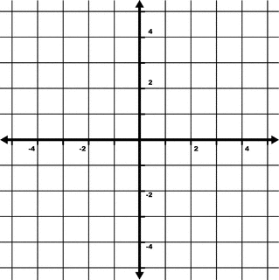 | 8. Find the length of side a below.  6 in. a  7 in. | 9. Find the measure of angle b.  b  32°
10. Put the following numbers in order from smallest to largest.  200%, 2¼, 2.5, 1 | 11. Estimate the sum below.  245,690 + 35,985 = | 12. Write as percent.  .38
13. Sara owes her mom $15. In order to pay her back she takes a job washing cars. She earns $2.50 for every car she washes.  Write an equation for the function. | 14. Graph Sara’s function.  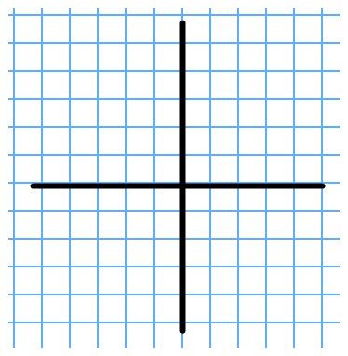 | 15. Complete the table.
  Cars washed | Sara’s money
  0
  5
  30
16. What is the sale price of a pair of $60 jeans that is marked 25% off? | 17. Find the volume of a sphere with a radius of 9 cm. | 18. A 5 pound bag of gummi bears was evenly divided into 40 bags. How many ounces of gummi bears were put into each bag?
19. Juan’s quiz scores are 7, 8, 7, 10, and 9. What is the mean of his quizzes? | 20. The distances traveled by a walking relay team were 3 km, 5000 m, and 1.5 km. How many total meters did the team travel? | Number correct  5 minutes_______  Total___________

